Result

Table of contents

**1 Selection of host strain** 1

**1.1 Preliminary screening of methanol-utilizing strains** 1

**1.2 Verification of methanol utilization by P16** 2

**1.3 Comparison of methanol utilization efficiency between P16 and control strains** 3

**1.4 Analysis of P16 tolerance to different methanol concentrations** 4

**1.5 Selection of the host strain P16** 5

**2 Design of gene editing tools** 5

**2.1 Design of the CRISPR-Cas9-Am knockout vector** 5

**2.2 Feasibility verification** 6

**2.3** **Conclusion** 7

**3 Analysis of the methanol metabolism pathway** 8

**4 Subcellular localization validation** 9

**5 Investigation of ribosome readthrough mechanism** 10

**6 Overexpression of key genes** 11

**7 Metabolic pathway engineering and optimization** 12

**8 Summary and future prospects** 14

# **1 Selection of host strain**

## **1.1 Preliminary screening of methanol-utilizing strains**

To select candidate strains with methanol-utilizing capability and superior growth performance, five marine-derived yeasts of *Aureobasidium melanogenum* (TN3-1, P16, ZW03-4, DH177, BZ) were cultivated in YPM medium containing 20 g/L methanol (composition: 2% peptone, 1% yeast extract, v/v 2% methanol) in shake flasks. OD₆₀₀ was measured as a growth indicator after 48 h. The results showed significant differences in growth among the five strains on methanol medium: P16 reached an average OD₆₀₀ of 1.30 ± 0.03 at 48 h, significantly higher than TN3-1 (0.50 ± 0.01), ZW03-4 (1.15 ± 0.04), DH177 (1.23 ± 0.05), and BZ (1.18 ± 0.05). Notably, P16 entered the logarithmic growth phase after 24 h and reached its maximum growth at 48 h. Overall, P16 exhibited the best adaptation under methanol conditions and was preliminarily selected as the host strain for subsequent studies.

|  |  |  |  |  |  |
| --- | --- | --- | --- | --- | --- |
|  | TN3-1 | P16 | ZW03-4 | DH177 | BZ |
| Group 1 | 0.516 | 1.256 | 1.170 | 1.224 | 1.115 |
| Group 2 | 0.492 | 1.320 | 1.188 | 1.317 | 1.212 |
| Group 3 | 0.504 | 1.316 | 1.101 | 1.137 | 1.221 |

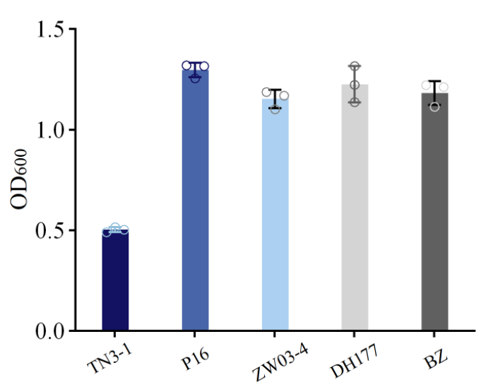

Figure 1 Growth of different strains in methanol-containing medium after 48 h

## **1.2 Verification of methanol utilization by P16**

To further validate the methanol utilization capability of P16, its growth was compared in media with and without methanol. Both groups were initially inoculated at OD₆₀₀ = 0.01. The results showed that P16 exhibited significantly higher growth rate and final biomass in YPM compared to YP: at 48 h, OD₆₀₀ reached 1.29 ± 0.05 in YPM, whereas it was only 0.50 ± 0.03 in YP. A t-test on the 48 h data (P < 0.05) confirmed statistical significance, demonstrating that P16 can utilize methanol as a carbon source.

|  |  |  |  |  |  |  |
| --- | --- | --- | --- | --- | --- | --- |
| Medium | YPM(with Methanol) | | | YP(without Methanol) | | |
| Group No. | 1 | 2 | 3 | 1 | 2 | 3 |
| 48 h OD600 | 1.256 | 1.320 | 1.316 | 0.501 | 0.503 | 0.497 |



Figure 2 Growth of P16 in YPM and medium YP

## **1.3 Comparison of methanol utilization efficiency between P16 and control strains**

To evaluate the methanol utilization level of P16, non-methylotrophic yeast *Saccharomyces cerevisiae* T and typical methylotrophic yeast *Komagataella pastoris* X33 were used as controls. All strains were cultured under the same YPM medium (20 g/L methanol) conditions. Initial inoculum densities were set at OD₆₀₀ = 0.01 for P16 and X33, and OD₆₀₀ = 0.1 for *S. cerevisiae* T due to its lower methanol tolerance. The results showed that at 48 h, X33 reached OD₆₀₀ = 3.00 ± 0.20, exhibiting the strongest methanol utilization capability. P16 was next, with OD₆₀₀ = 1.03 ± 0.02, significantly higher than S. cerevisiae. Overall, while P16’s methanol utilization efficiency is lower than X33, it is significantly higher than the non-methylotrophic yeast, demonstrating its potential as a chassis for methanol metabolism studies.

|  |  |  |  |  |  |  |  |  |  |
| --- | --- | --- | --- | --- | --- | --- | --- | --- | --- |
|  | *A.melanogenum* P16 | | | *K.pastoris* X33 | | | *S.cerevisiae* | | |
| 0 h | 0.010 | 0.010 | 0.010 | 0.010 | 0.010 | 0.010 | 0.100 | 0.100 | 0.100 |
| 12 h | 0.307 | 0.284 | 0.291 | 0.200 | 0.203 | 0.196 | 0.284 | 0.284 | 0.280 |
| 24 h | 1.385 | 1.475 | 1.375 | 1.330 | 1.340 | 1.345 | 0.309 | 0.303 | 0.302 |
| 36 h | 1.370 | 1.460 | 1.440 | 2.470 | 2.265 | 2.450 | 0.308 | 0.304 | 0.297 |
| 48 h | 1.025 | 1.050 | 1.020 | 3.195 | 3.245 | 2.780 | 0.310 | 0.302 | 0.309 |



Figure 3 Growth curves of *Aureobasidium melanogenum* P16 and control strains in methanol medium

## **1.4 Analysis of P16 tolerance to different methanol concentrations**

To determine the methanol tolerance range of P16, cultures were grown in YPM medium containing 10, 20, 30, 40, and 50 g/L methanol, with an initial inoculum of OD₆₀₀ = 0.01 for all groups. The results showed that P16 grew optimally under 20–30 g/L methanol conditions. When the methanol concentration increased to 50 g/L, growth was significantly inhibited. These results indicate that P16 can stably grow within the 10–40 g/L methanol range, with 20–30 g/L being the most suitable concentration.

|  |  |  |  |  |  |  |  |  |  |
| --- | --- | --- | --- | --- | --- | --- | --- | --- | --- |
|  | Methanol 10g/L | | | Methanol 20g/L | | | Methanol 30g/L | | |
| 0 h | 0.010 | 0.010 | 0.010 | 0.010 | 0.010 | 0.010 | 0.010 | 0.010 | 0.010 |
| 12 h | 0.413 | 0.387 | 0.375 | 0.290 | 0.304 | 0.292 | 0.243 | 0.183 | 0.192 |
| 24 h | 1.083 | 1.057 | 1.007 | 0.975 | 0.982 | 0.975 | 0.827 | 0.723 | 0.767 |
| 36 h | 1.835 | 1.695 | 1.645 | 1.505 | 1.455 | 1.415 | 0.907 | 0.870 | 0.882 |
| 48 h | 1.220 | 1.280 | 1.350 | 1.275 | 1.325 | 1.375 | 1.195 | 1.035 | 0.965 |
| 60 h | 1.100 | 1.145 | 1.145 | 1.195 | 1.350 | 1.180 | 1.105 | 0.925 | 0.935 |
| 72 h | 0.955 | 0.960 | 0.975 | 0.840 | 1.035 | 0.985 | 0.935 | 0.885 | 0.850 |
|  | Methanol 40g/L | | | Methanol 50g/L | |
| 0 h | 0.010 | 0.010 | 0.010 | 0.010 | 0.010 |
| 12 h | 0.143 | 0.119 | 0.132 | 0.105 | 0.104 |
| 24 h | 0.522 | 0.278 | 0.365 | 0.129 | 0.105 |
| 36 h | 0.778 | 0.490 | 0.543 | 0.154 | 0.114 |
| 48 h | 0.744 | 0.616 | 0.650 | 0.157 | 0.110 |
| 60 h | 0.825 | 0.700 | 0.710 | 0.168 | 0.128 |
| 72 h | 0.616 | 0.719 | 0.501 | 0.312 | 0.115 |



Figure 4 Growth curves of *Aureobasidium melanogenum* P16 at different methanol concentrations

## **1.5 Selection of the host strain P16**

In summary, *Aureobasidium melanogenum* P16 exhibits both methanol utilization capability and a relatively wide tolerance range. Therefore, it was selected as the host strain for this study and sent to a biotechnology company for whole-genome sequencing and annotation.

# **2 Design of gene editing tools**

## **2.1 Design of the CRISPR-Cas9-Am knockout vector**

In this study, based on the Seamless Cloning principle, the p414-TEF1p-Cas9-CYC1t plasmid was first linearized. Then, the nourseothricin resistance gene (*NAT*), the *Aspergillus* AMA1 autonomous replicating sequence, and the synthesized fragment U6 Promoter + sgRNA-gRNA scaffold + U6 Terminator were sequentially inserted to construct Cas9-NAT and Cas9-NAT-AMA1, ultimately generating the CRISPR-Cas9-Am knockout vector for *Aureobasidium melanogenum*.



Figure 5 Schematic diagram of the construction of the CRISPR-Cas9-Am knockout vector

## **2.2 Feasibility verification**

To visually and accurately evaluate the function of the constructed CRISPR-Cas9-Am knockout vector, the *Ade*2 gene was selected as the target.

Using the CRISPOR website, the CDS sequence of *Ade*2 from the P16 strain was input into Step 1: Input. In Step 2, the *Aureobasidium* pullulan genome data were selected, and in Step 3, 20 bp-NGG-SpCas9 was chosen, followed by submission.

The predicted optimal sgRNA parameters are summarized in the following table:

|  |  |  |  |  |  |  |
| --- | --- | --- | --- | --- | --- | --- |
| Position/Strand | Guide sequence + PAM | MIT Specificity score | CFD Specificity score | Predicted efficiency | Result | Off-targets with 0-1-2-3-4 mismatches + near PAM |
| 81/Reverse（rev） | CTGCCTC CAGAATG TTGACT  +TGG | 100 | 100 | Doench '16: 44  Mor-Mateos:53  Doench-RuleSet3:-76 | Frameshift: 55  Lindel: 71 | 0 - 0 - 0 - 0 - 2  0 - 0 - 0 - 0 - 0  2 off-targets |

The above sgRNA sequence was inserted into the plasmid vector as its reverse complementary strand:

5’-AGTCAACATTCTGGACGCAG-3’

The designed primers and gene-synthesized fragments were sent to Qingdao Qingke Biotech for synthesis, yielding the CRISPR-Cas9-Am-ΔAde2 knockout vector.

Correctly sequenced plasmids were transformed into *Aureobasidium melanogenum* P16 via the protoplast transformation method. Cultures were incubated at 28°C, and growth was observed. Results from the rescreening plates are shown in the figure. A clear difference in colony color was observed between the *Ade*2 knockout and the wild-type. The deletion of the *Ade*2 gene blocks adenine biosynthesis, leading to accumulation of red metabolic intermediates and resulting in a red colony phenotype. This confirms that the CRISPR-Cas9-Am vector was successfully constructed and can be used for gene knockout in *Aureobasidium melanogenum* P16.

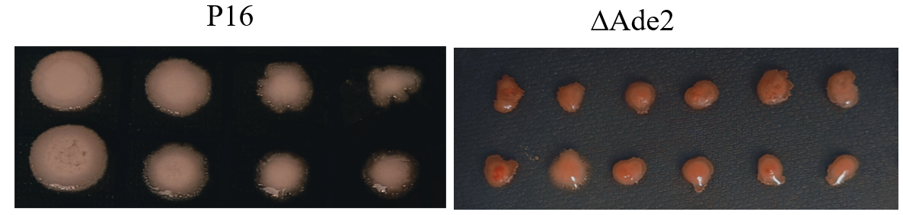



Figure 6 Phenotypic validation (100% NAT-resistant rescreening plate)

## **2.3 Conclusion**

By targeting the *Ade*2 gene, this study verified the editing feasibility of the constructed CRISPR-Cas9-Am vector in *Aureobasidium melanogenum* P16. The colony color change resulting from *Ade*2 deletion provides a direct and reliable phenotypic marker, demonstrating that the vector can achieve efficient site-specific gene knockout. Subsequent repeated use of this system in the laboratory showed a positive editing rate of 50%–80%.

# **3 Analysis of the methanol metabolism pathway**

Based on KEGG genome annotation and BioEdit sequence alignment results, this study confirmed that *Aureobasidium melanogenum* P16 contains a complete set of methanol metabolism-related genes. Subcellular localization prediction indicated that these enzymes are distributed in organelles such as peroxisomes.

According to KEGG annotation, methanol metabolism in P16 primarily occurs in the peroxisomes and is closely linked with cytosolic and mitochondrial carbon and energy metabolism pathways. Initially, methanol is oxidized to formaldehyde by alcohol oxidases (Aox1, Aox2), producing hydrogen peroxide as a byproduct. Formaldehyde is then converted, via dihydroxyacetone synthase (Das) and xylulose-5-phosphate (Xu5P), into dihydroxyacetone (DHA) and glyceraldehyde-3-phosphate (G3P). DHA is further phosphorylated by dihydroxyacetone kinase (Dak) to form dihydroxyacetone phosphate (DHAP). DHAP can be isomerized to G3P and enter the glycolytic pathway, gradually producing pyruvate. Simultaneously, DHAP can condense with G3P via fructose-1,6-bisphosphate aldolase (Fba) to form fructose-1,6-bisphosphate (FBP), which is then converted to fructose-6-phosphate (F6P) by fructose-1,6-bisphosphatase (Fbp) and further isomerized to glucose-6-phosphate (G6P). G6P can serve both as an intermediate for carbon flux distribution in central metabolism and, via phosphoglucomutase (PGM), be converted to glucose-1-phosphate (G1P), a precursor for pullulan biosynthesis. On the other hand, pyruvate entering the mitochondria is converted into acetyl-CoA, which enters the tricarboxylic acid (TCA) cycle, producing sequentially citrate, isocitrate, succinate, fumarate, malate, and oxaloacetate, thereby contributing to energy production and reducing power supply.

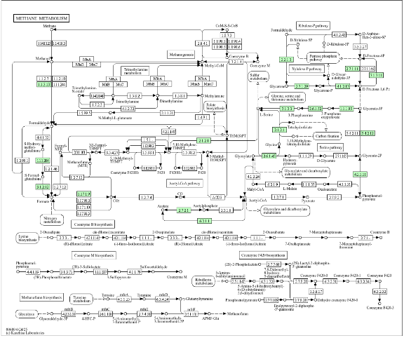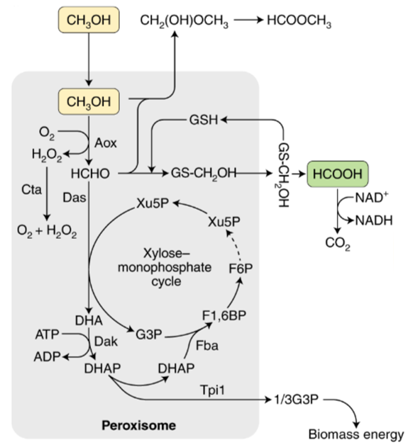

Figure 7 Methanol metabolism pathway in *Aureobasidium melanogenum* P16

# **4 Subcellular localization validation**

The mCherry-SKL vector was constructed using restriction enzyme digestion and ligation, and subsequently introduced into the *Aureobasidium melanogenum* P16 strain via electroporation, enabling localization of mCherry to intracellular peroxisomes. Following the same approach, a GFP vector was constructed. The target gene was then cloned downstream of GFP using restriction-ligation techniques to generate GFP–target gene fusion expression vectors. Colony PCR was performed using the corresponding primers, and the PCR products were verified by agarose gel electrophoresis, with results shown below.



Figure 8 Colony PCR verification of GFP-AOX2 (3016 bp)



Figure 9 Colony PCR verification of GFP-AOX1(2971bp)

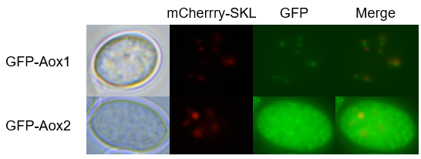These vectors were then electroporated into P16 transformants already containing mCherry-SKL, and subcellular localization of the target genes was analyzed via fluorescence microscopy. For Aox1, green fluorescent signals appeared as distinct puncta that overlapped with the red mCherry-SKL peroxisomal markers. In the merged channel, these signals formed orange-yellow punctate spots, indicating that Aox1 protein is primarily localized in peroxisomes. For Aox2, green fluorescence was distributed diffusely throughout the cytoplasm, while partial colocalization with the red peroxisomal markers was also observed, suggesting that Aox2 is present both in the cytoplasm and partially within peroxisomes. These subcellular localization experiments confirm that peroxisomes serve as an important site for methanol metabolism.

Figure 10 Subcellular localization of Aox1 and Aox2 in *Aureobasidium melanogenum* P16

# **5 Investigation of ribosome readthrough mechanism**

By constructing different fluorescent fusion proteins and observing their localization in cells, this study analyzed the subcellular localization characteristics of DAS and DAK.

Colony PCR was performed using the corresponding primers to preliminarily verify the correctness of the vectors, and the electrophoresis results are shown below.



Figure 11 Colony PCR verification of GFP-Das



Figure 12 Colony PCR verification of GFP-Das cyt



Figure 13 Colony PCR verification of GFP-Das pex



Figure 14 Colony PCR verification of GFP-Dak



Figure 15 Colony PCR verification of GFP-Dak cyt



Figure 16 Colony PCR verification of GFP-Das pex

The results showed that GFP-Das exhibited diffuse fluorescence in the cytoplasm. When the potential peroxisomal targeting signal (PTS) sequence at the C-terminus was removed (GFP-Dascyt), the green fluorescence was distributed diffusely in the cytoplasm and showed almost no colocalization with the peroxisome marker. The fluorescence of GFP-Daspex mainly appeared as cytoplasmic diffusion, with no obvious punctate fluorescence colocalizing with peroxisomes, indicating that simulating readthrough via stop codon mutation was not effective. Therefore, these results do not yet support the conclusion that its localization depends on a ribosome readthrough mechanism. Further verification will be conducted through overexpression experiments.

For DAK, GFP-Dak showed green fluorescence that was both colocalized with the peroxisomal marker and diffusely distributed in the cytoplasm. When the potential downstream PTS was removed (GFP-DakCvt), fluorescence was restricted to the cytoplasm, lacking peroxisomal colocalization. In contrast, the construct with a mutation at the first stop codon to mimic ribosome readthrough (GFP-Dakpex) exhibited distinct punctate green fluorescence that clearly overlapped with peroxisomal markers, indicating that DAK’s peroxisomal localization depends on ribosome readthrough exposing a downstream cryptic PTS.

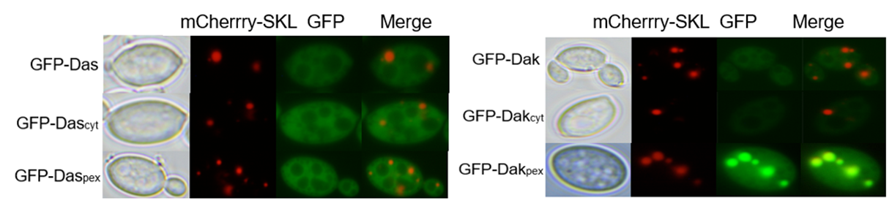

Figure 17 Subcellular localization of Das, Dak, and their mutant constructs in *Aureobasidium melanogenum* P16

# **6 Overexpression of key genes**

For the P16 strain, the Das gene from *Komagataella pastoris* was overexpressed, and the growth of the recombinant strain was compared with the wild-type P16 in YPM medium containing methanol over 48 hours.

The wild-type P16 and the transformants were verified using the P.p Das-F and P.p Das-R primers. The electrophoresis results are shown in the figure, indicating that the P.p Das gene was successfully overexpressed.

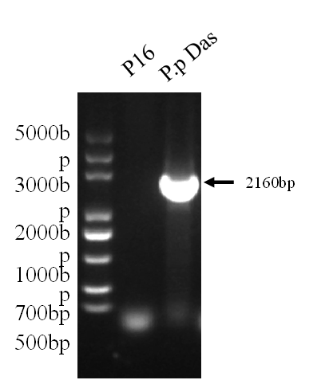

Figure 18 Colony PCR verification of P.p Das

In the growth comparison, the wild-type P16 showed OD₆₀₀ values of 1.256, 1.320, and 1.316, with an average of 1.297. The recombinant strain overexpressing Das exhibited OD₆₀₀ values of 1.452, 1.450, and 1.472, with an average of 1.458. Compared with the wild type, the overexpression strain showed a significant increase in cell density, indicating that the overexpression of the heterologous Das gene can enhance growth under methanol-containing conditions.

Thus, overexpression of the *K. pastoris* Das gene in P16 promotes methanol metabolism, improving the growth of P16 when methanol is the sole carbon source.

|  |  |  |  |  |  |  |
| --- | --- | --- | --- | --- | --- | --- |
| Strain | P16 (Wild type) | | | P.p Das (Das overexpression) | | |
| Group | 1 | 2 | 3 | 1 | 2 | 3 |
| OD 600 | 1.256 | 1.320 | 1.316 | 1.452 | 1.450 | 1.472 |



Figure 19 Comparison of 48-h growth of P16 wild-type and Das overexpression strains in methanol-containing medium

# **7 Metabolic pathway engineering and optimization**

A recombinant *E. coli* strain, YihX, expressing the haloacid dehalogenase-like phosphatase gene (yihX) was constructed. Colony PCR was performed using the corresponding primers for verification, and the electrophoresis results are shown below.

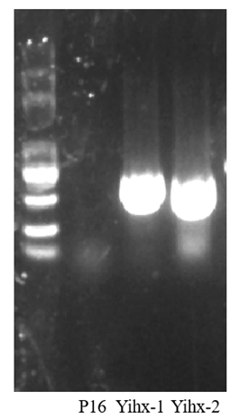

Figure 20 Colony PCR verification of Yihx

In YPM medium containing methanol, the glucose production was measured after 48 h of fermentation for the wild-type *Aureobasidium melanogenum* P16 strain and the recombinant strain *Yih*X, which heterologously expresses the *E. coli* haloacid dehalogenase-like phosphatase gene (*yih*X). The results are shown in the figure below.

|  |  |  |  |  |  |  |
| --- | --- | --- | --- | --- | --- | --- |
| Strain | P16 | | | Yihx | | |
| Group | 1 | 2 | 3 | 1 | 2 | 3 |
| Glucose production（g/L） | 0.045 | 0.034 | 0.042 | 0.041 | 0.047 | 0.038 |

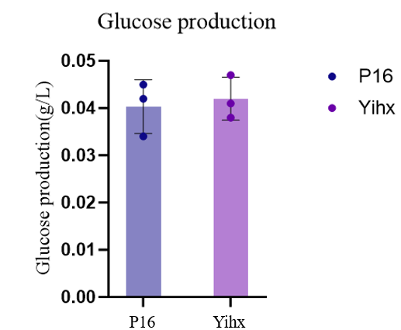

Figure 21 Comparison of glucose production between wild-type P16 and heterologous YihX-expressing strains

Significance testing of the results showed no significant difference in glucose production between the wild-type P16 strain and the heterologous YihX-expressing strain.

The phosphofructokinase gene (pfk) in the YihX strain was knocked out using the CRISPR-Cas9-NAT-Am plasmid, generating the YihX-Δpfk strain. Recombinant colonies were selected and sequenced, and the sequencing results are shown below.

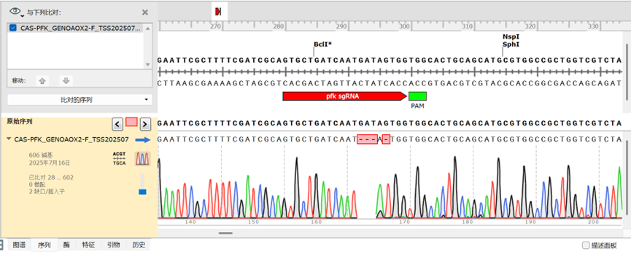

Figure 22

The Pfk knockout transformant sequence is shown below, with the **pfk sgRNA** highlighted in red and the **PAM** sequence highlighted in green:

CGCTTTTCGATCGCAGTGCTGATCAAT---A-TGGTGGCACTGCAGCATGCGTGGC

Wild-type P16 and the **YihX-Δpfk** recombinant strain were cultured on YPGL medium (glucose-free, containing glycerol and lactose) and on YPD medium. The **YihX-Δpfk** strain was unable to grow on YPGL medium, indicating that it cannot utilize glucose.

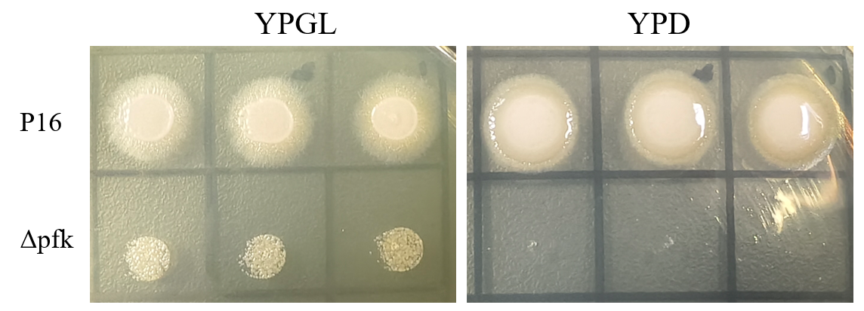

Figure 23 Growth of P16 strain and Δpfk strain on YPGL and YPD media

For the wild-type P16 strain and the CRISPR-Cas9-NAT-Am-mediated phosphofructokinase (*pfk*) knockout strain, the glucose production of wild-type P16 was 0.045, 0.034, and 0.042 g/L, with an average of 0.040 g/L. In contrast, the YihX-Δpfk recombinant strain produced 0.891, 0.789, and 0.851 g/L glucose, with an average of 0.844 g/L. Compared with the wild-type, the recombinant strain showed a significant increase in glucose production, exceeding a 20-fold improvement.

|  |  |  |  |  |  |  |  |
| --- | --- | --- | --- | --- | --- | --- | --- |
| Strain | P16 | | | Yihx-Δpfk | | | |
| Group No. | 1 | 2 | 3 | | 1 | 2 | 3 | |
| Glucose production（g/L） | 0.045 | 0.034 | 0.042 | | 0.891 | 0.789 | 0.851 | |

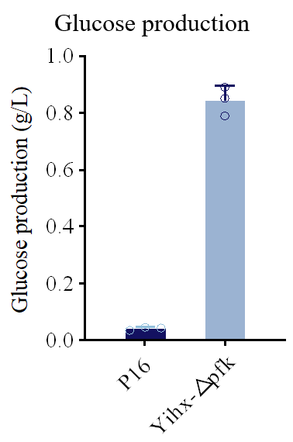

Figure 24 Comparison of 48-hour glucose production in methanol-containing medium between wild-type P16 and YihX-Δpfk recombinant strain

By knocking out the key glycolytic enzyme gene *pfk* and introducing the heterologous *yih*X gene, glucose synthesis in P16 under methanol conditions was significantly enhanced, demonstrating the effectiveness of this metabolic engineering strategy.

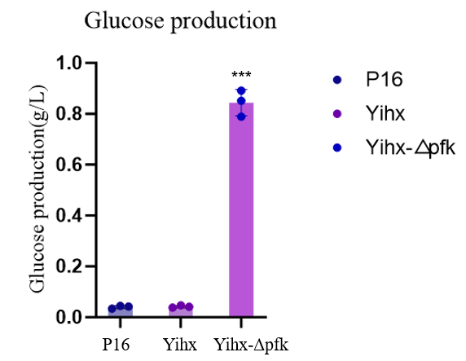

Figure 25 Comparison of 48-hour glucose production in methanol-containing medium among wild-type P16, heterologous YihX-expressing strain, and YihX-Δpfk recombinant strain

# **8 Summary and future prospects**

In this project, the marine yeast *Aureobasidium melanogenum* P16, which exhibits superior methanol metabolism, was selected as the chassis strain for synthetic biology modifications. Using seamless cloning technology, a CRISPR-Cas9-Am gene knockout vector specifically tailored for *A. melanogenum* was successfully constructed. Experimental validation demonstrated that this system could efficiently perform gene editing in the P16 strain, filling a gap in the availability of high-efficiency genetic tools for *A. melanogenum*. Combined with KEGG annotation, BioEdit sequence alignment, and fluorescence localization experiments, the complete methanol metabolic pathway in P16 and the subcellular distribution of key enzymes were elucidated. The study further revealed, for the first time, the role of ribosome readthrough in the localization of key methanol metabolism enzymes through the construction of fluorescent fusion proteins. Overexpression of the *Pichia pastoris* g Das ene significantly enhanced P16 growth in methanol-containing medium. Moreover, deletion of the glycolytic key enzyme *pfk* and heterologous expression of the *E. coli yih*X gene increased glucose production in the recombinant strain from 0.040 g/L to 0.844 g/L, achieving more than a 20-fold improvement.

Future research may focus on further optimizing the gene editing system to improve efficiency and expand its functionality; integrating omics and metabolic analyses to explore regulatory mechanisms and carbon flux bottlenecks in methanol metabolism; performing multi-gene coordinated engineering to enhance methanol utilization and target product synthesis; and scaling up fermentation processes for industrial validation, ultimately advancing the application of P16 in methanol-based biomanufacturing.